HC 2 T2 U1
 | 題目 | 圖片
1 | I like bananas. | 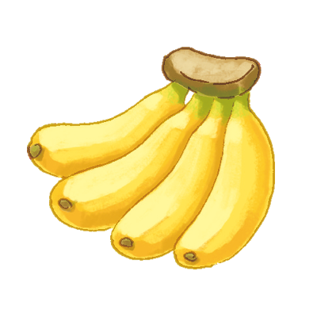
2 | I like papayas. | 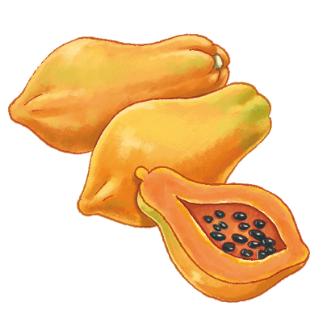
3 | I like oranges. | 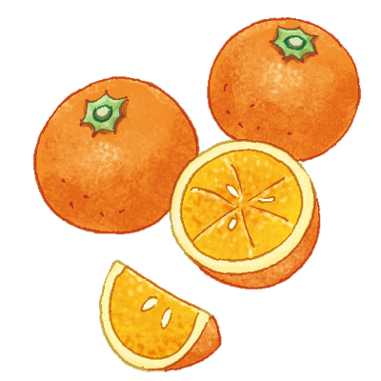
4 | I like grapes. | 